Name ____________________
Date _____________________
Period _____ Group _____
All About You

- Go to the following website and fill out the Google Form to tell me more about you. www.darwinia.weebly.com
- On the graph below put ONE DOT that shows where you are starting the year in science. Do you feel like you have learned a lot of science in the past? Do you love science? Do you hate it?
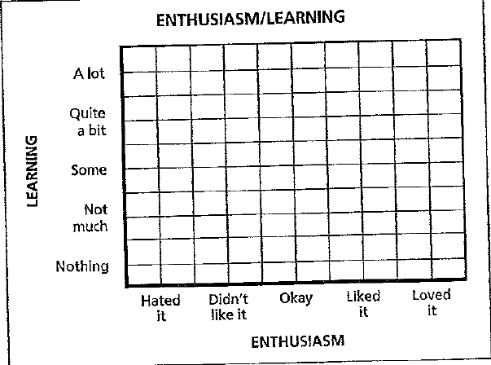
- Explain why you feel this way about science right now.
____________________________________________________________________________________________________________________________________________________________________________________________________________________________________________________________________________________________________________________________________________________

- GOALS FOR THIS YEAR

  - What do you hope to achieve in science?

  - What are your life goals?

  - Think about all your answers from the questions above to create your science class goal for this year.
My science class goal:

